Load cell
# Source: AI Source: Provided by: [Data Path: Persons Table -> ID Column: 1, Name_En Column: Motasem Essam] -> From: [ChatGPT] on [7/17/2026]
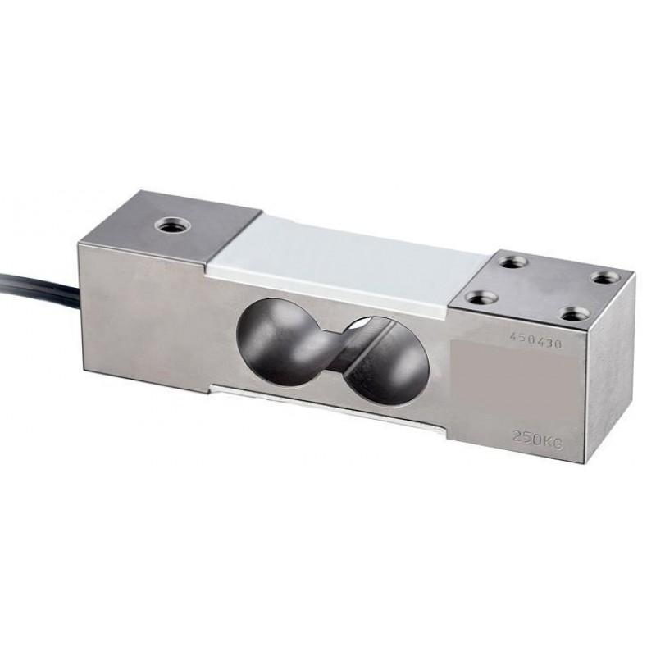
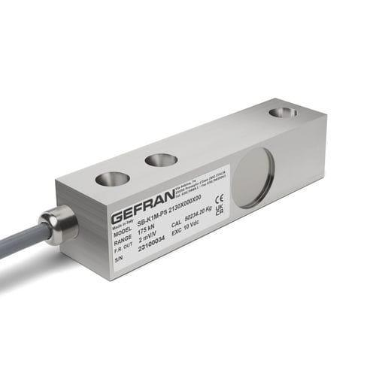
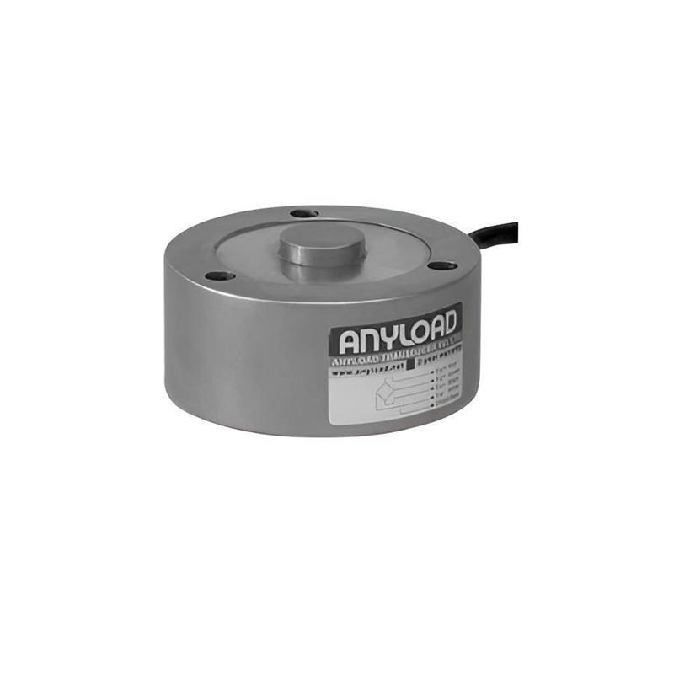
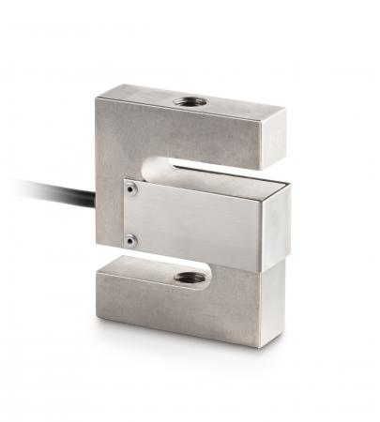
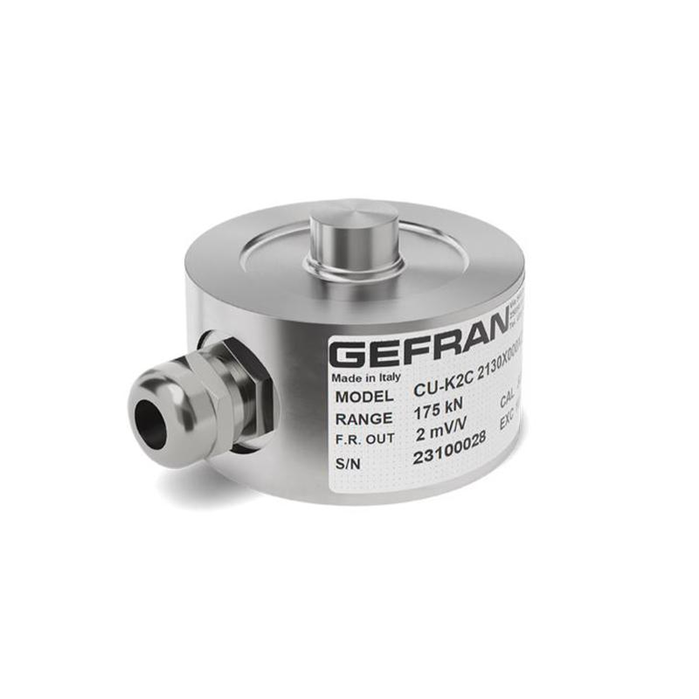
A Load Cell is a force-measuring sensor that converts an applied force or weight into an electrical signal. It is one of the most widely used force-measuring devices in industrial weighing systems, electronic scales, material testing, structural monitoring, automation, aerospace, and research laboratories.
Most modern load cells use strain gauges, which change electrical resistance when deformed under load.

Definition
# Source: AI Source: Provided by: [Data Path: Persons Table -> ID Column: 1, Name_En Column: Motasem Essam] -> From: [ChatGPT] on [7/17/2026]
A Load Cell is a transducer that converts a mechanical force into a measurable electrical signal.

Purpose
# Source: AI Source: Provided by: [Data Path: Persons Table -> ID Column: 1, Name_En Column: Motasem Essam] -> From: [ChatGPT] on [7/17/2026]
A load cell is used to:
- Measure force.
- Measure weight.
- Measure compression loads.
- Measure tension loads.
- Monitor structural loads.
- Control industrial processes.
- Perform precision laboratory measurements.

Principle of Operation
# Source: AI Source: Provided by: [Data Path: Persons Table -> ID Column: 1, Name_En Column: Motasem Essam] -> From: [ChatGPT] on [7/17/2026]
Most load cells operate using strain gauge technology.
When force is applied:
- The metal element deforms slightly.
- The bonded strain gauges stretch or compress.
- Their electrical resistance changes.
- A Wheatstone bridge converts this change into a voltage signal.
- Electronics convert the signal into force or weight.

Main Components
# Source: AI Source: Provided by: [Data Path: Persons Table -> ID Column: 1, Name_En Column: Motasem Essam] -> From: [ChatGPT] on [7/17/2026]
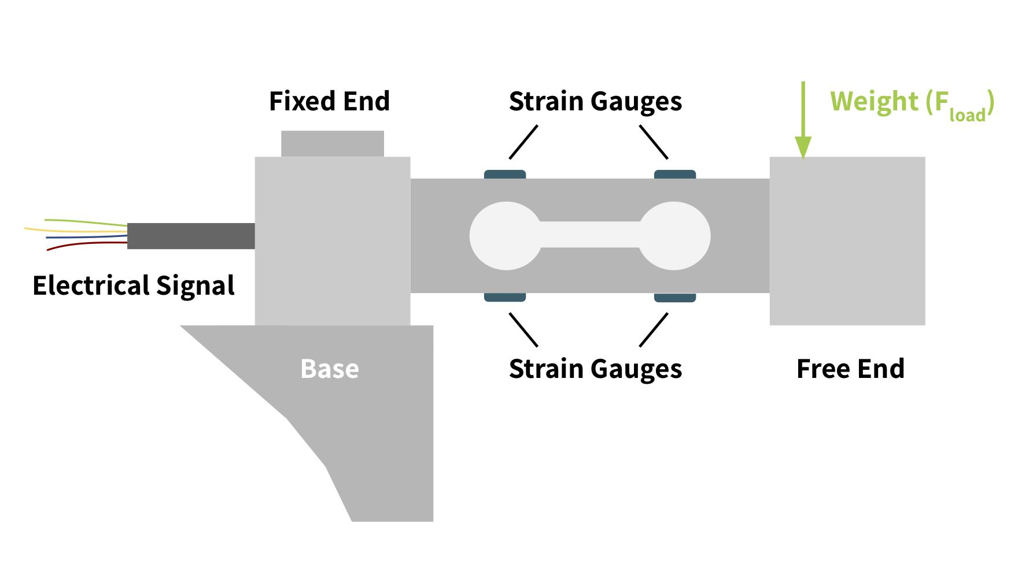
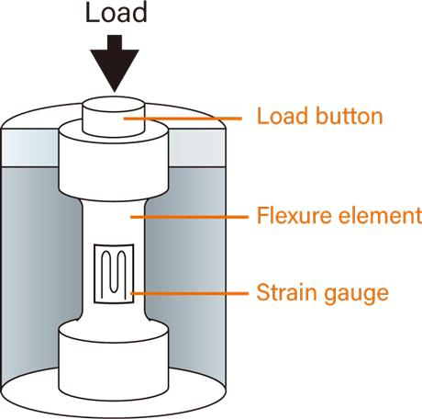
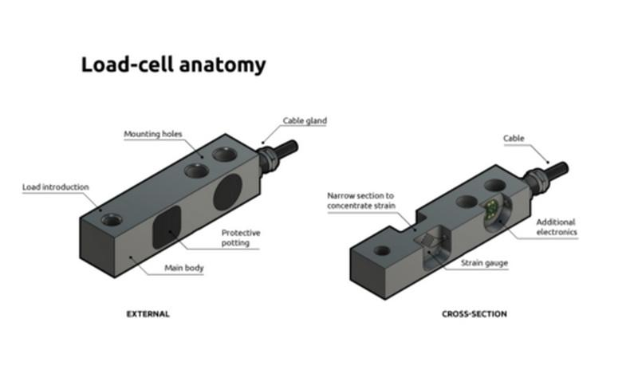
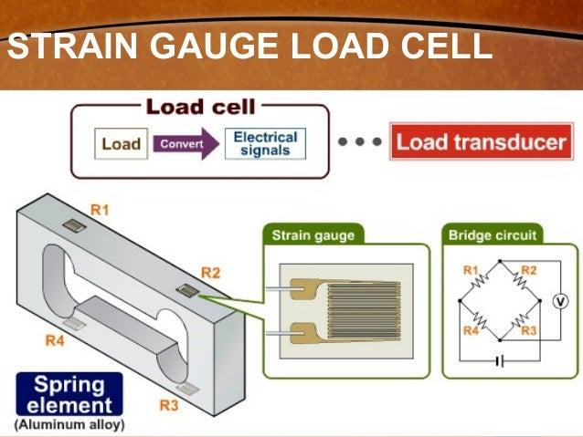
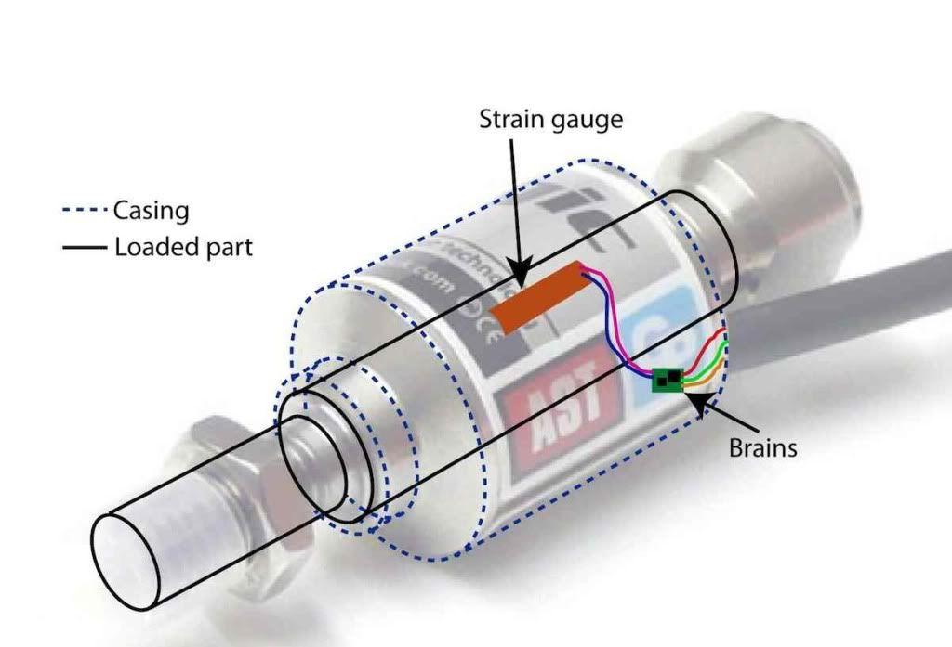
A typical load cell consists of:
- Elastic metal body
- Strain gauges
- Wheatstone bridge circuit
- Protective housing
- Electrical cable
- Mounting holes

Types of Load Cells

1. Single Point Load Cell
# Source: AI Source: Provided by: [Data Path: Persons Table -> ID Column: 1, Name_En Column: Motasem Essam] -> From: [ChatGPT] on [7/17/2026]
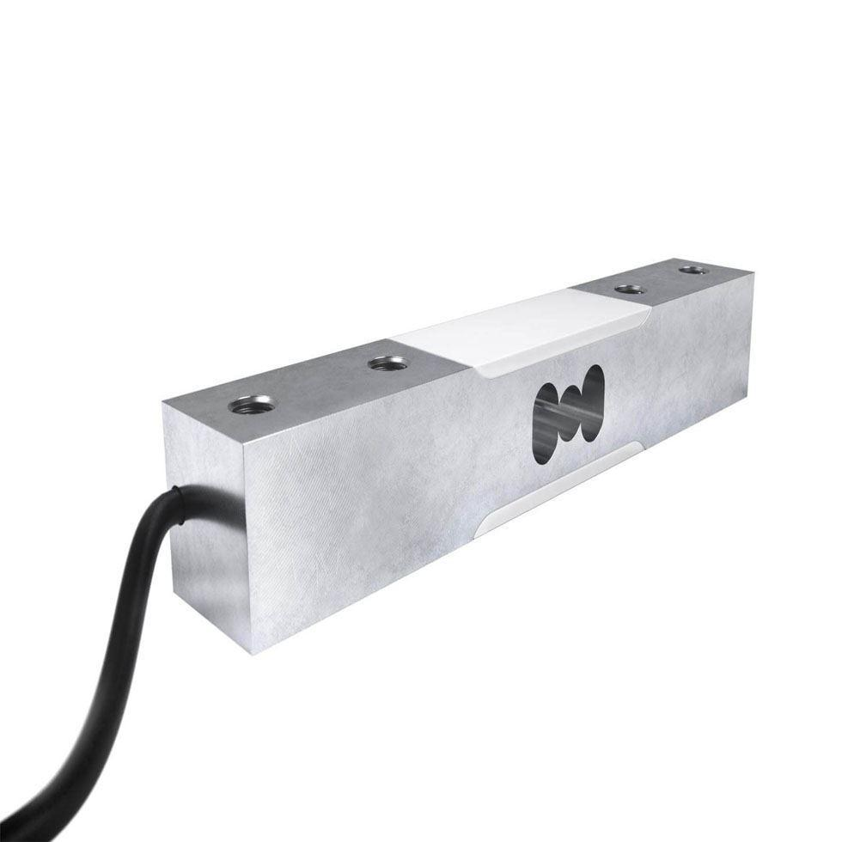
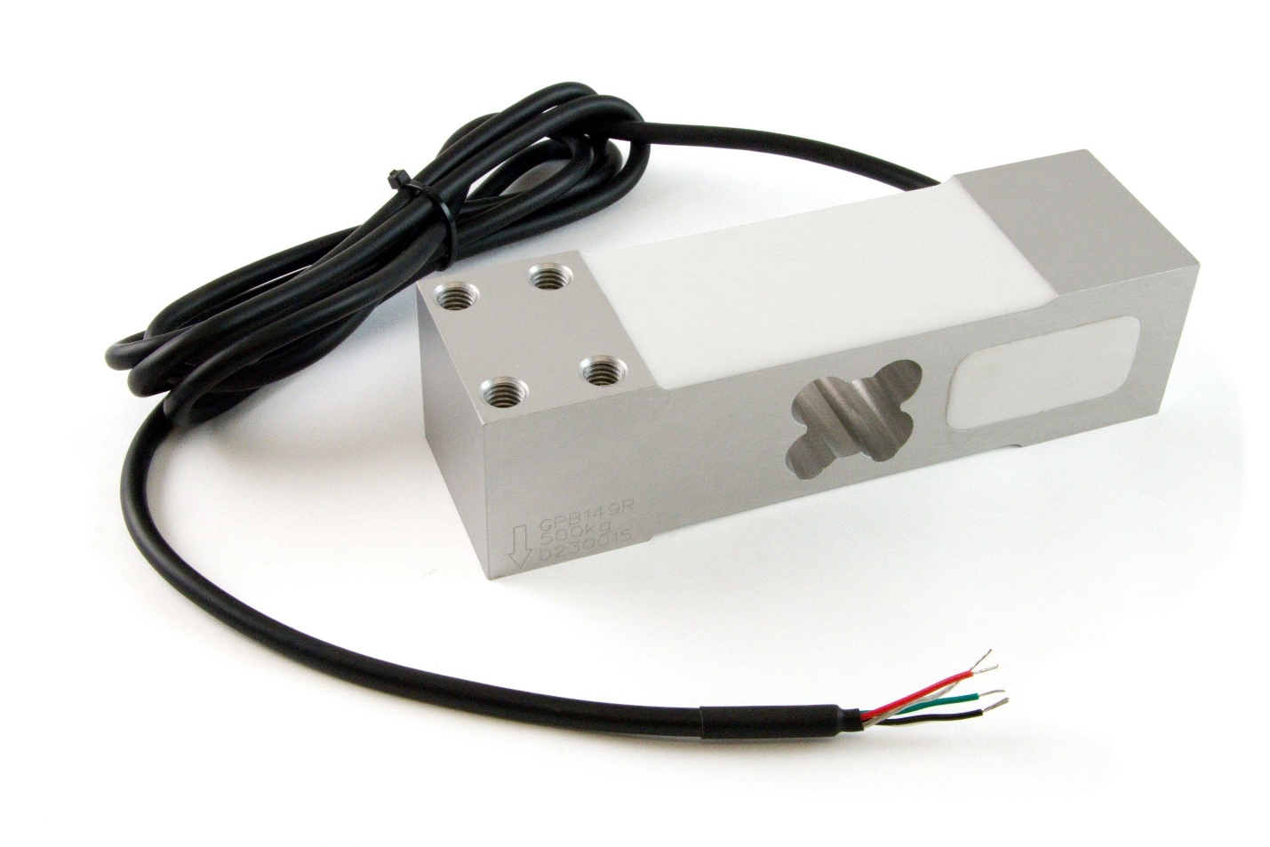
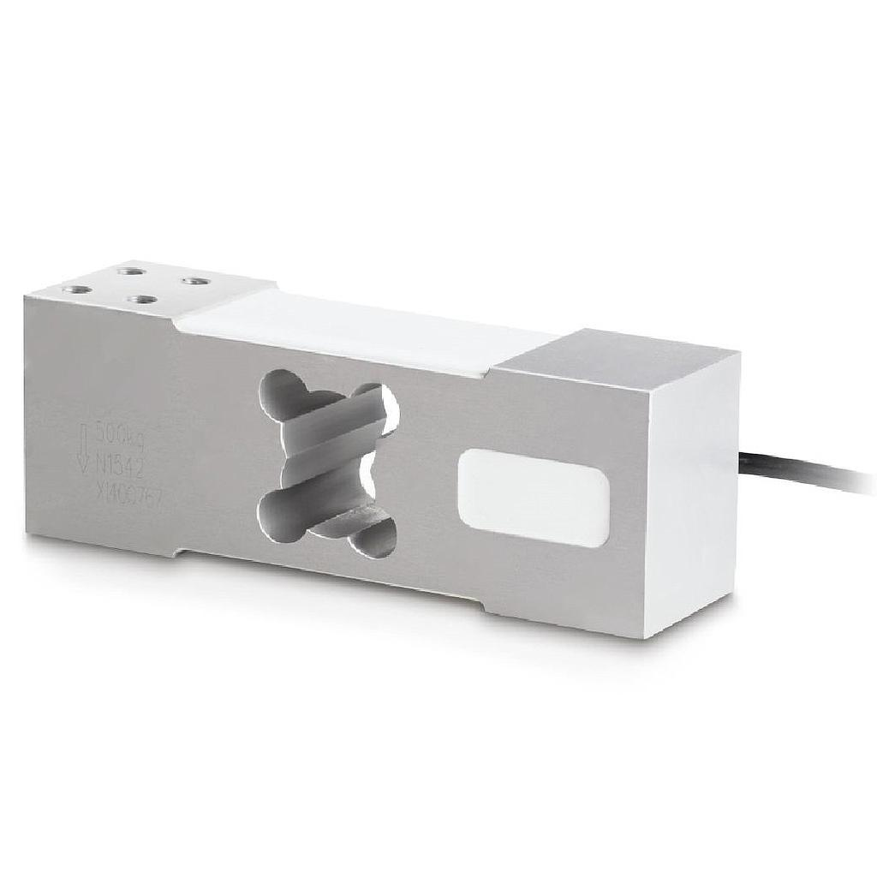
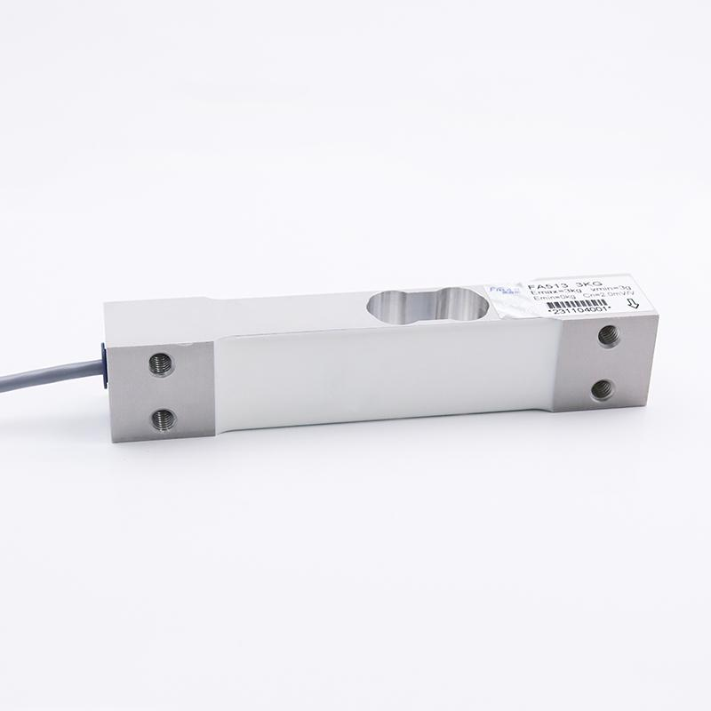
Description
Designed for platform scales where the load may be applied anywhere on the weighing platform while maintaining high accuracy.
Applications
- Bench scales
- Retail scales
- Postal scales
- Platform balances

2. Shear Beam Load Cell
# Source: AI Source: Provided by: [Data Path: Persons Table -> ID Column: 1, Name_En Column: Motasem Essam] -> From: [ChatGPT] on [7/17/2026]
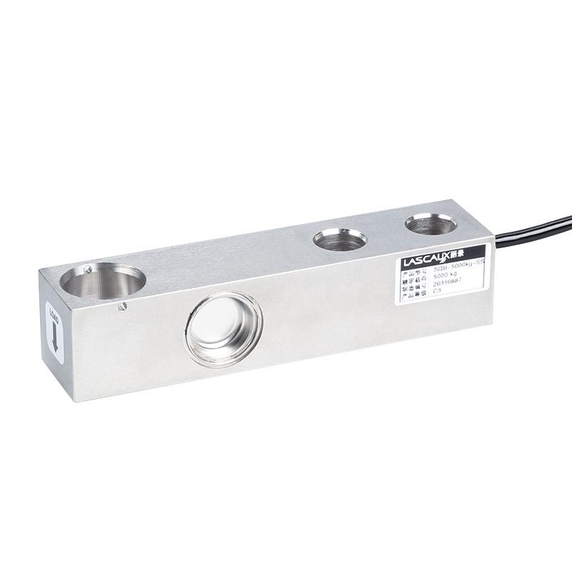

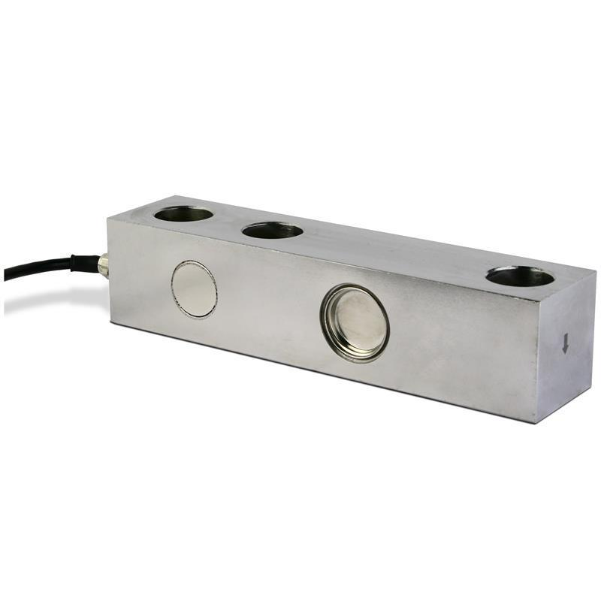
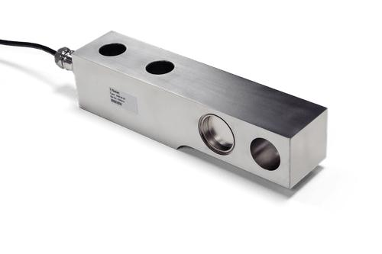
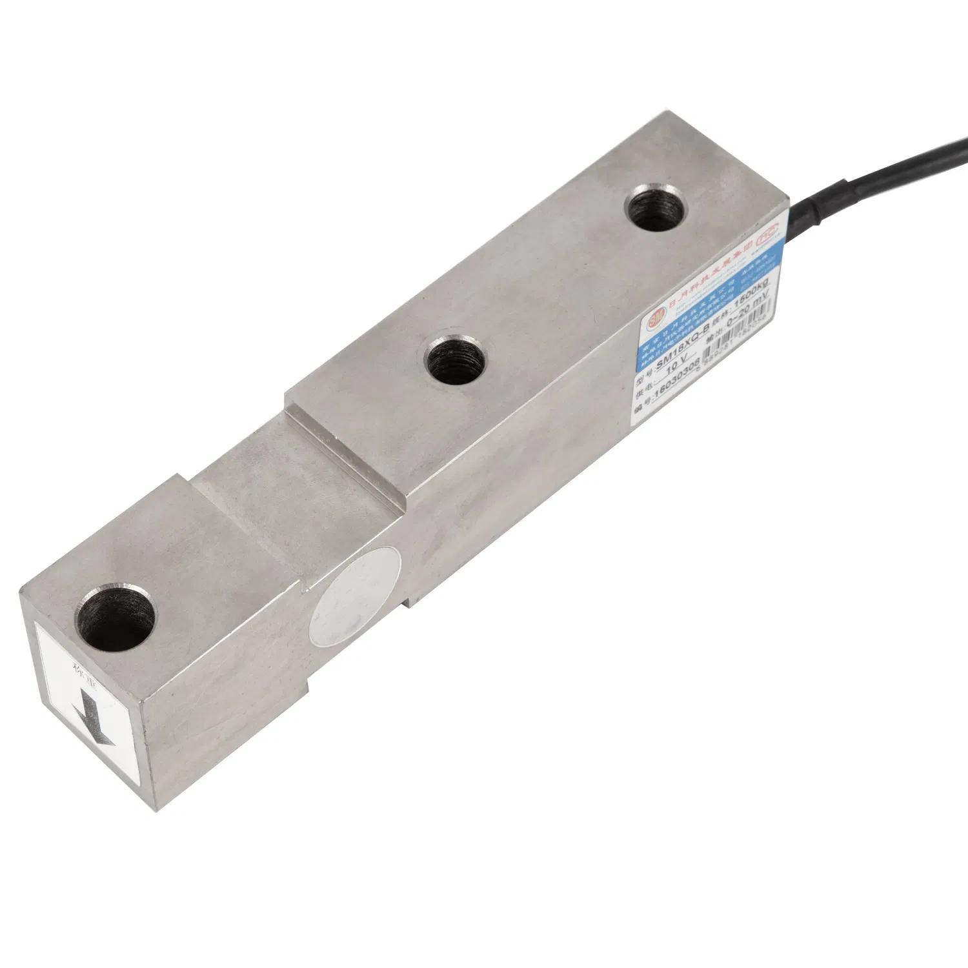
Description
Measures force through shear deformation of the beam. It is one of the most common industrial load cells.
Applications
- Floor scales
- Tank weighing
- Hopper weighing
- Industrial weighing systems

3. Compression Load Cell
# Source: AI Source: Provided by: [Data Path: Persons Table -> ID Column: 1, Name_En Column: Motasem Essam] -> From: [ChatGPT] on [7/17/2026]

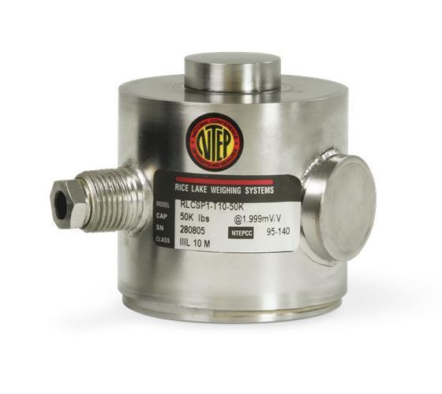
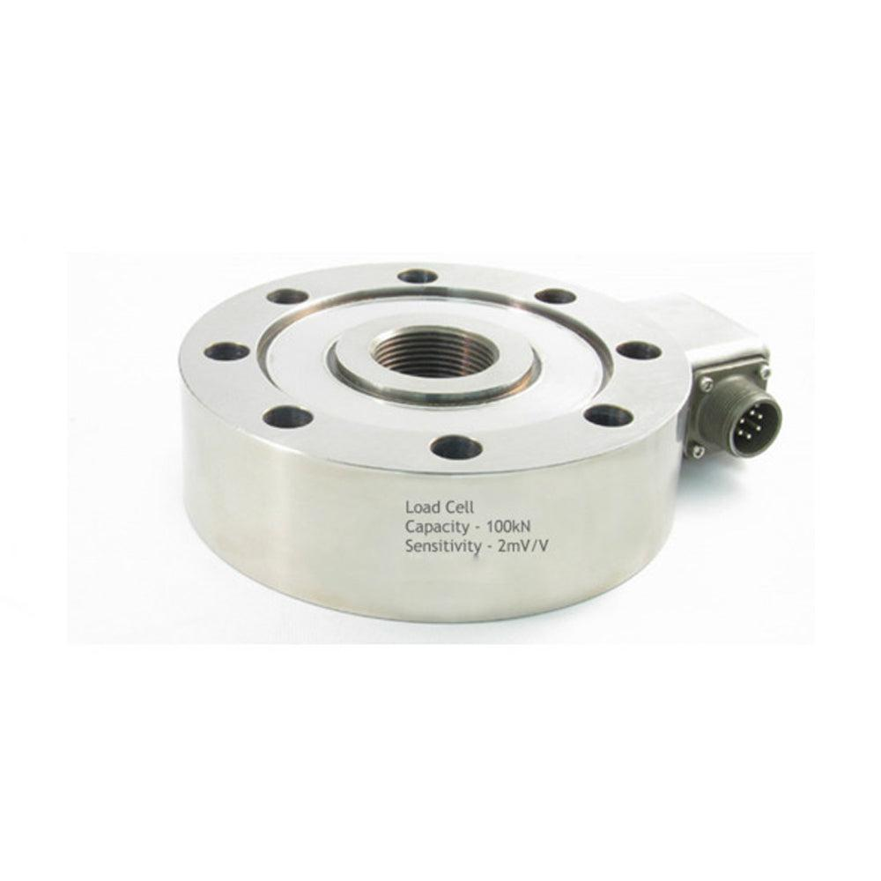
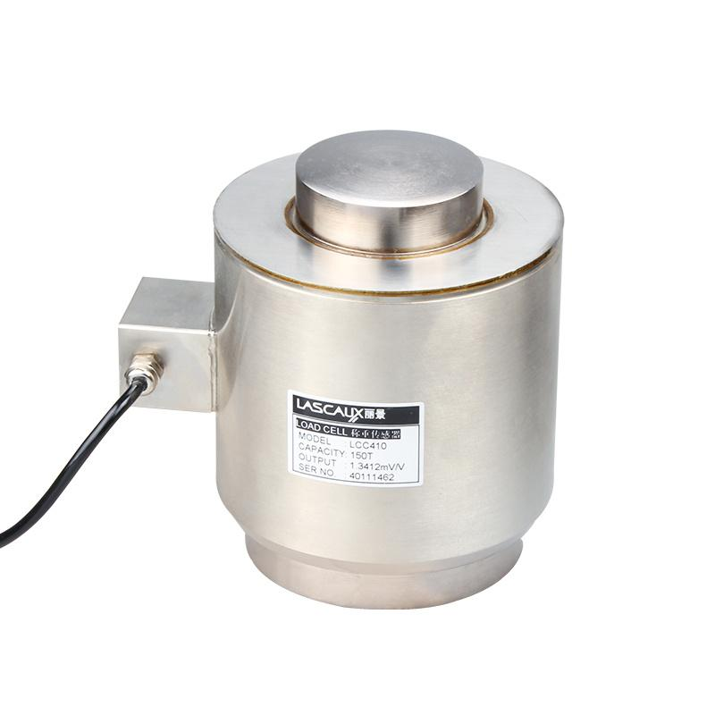
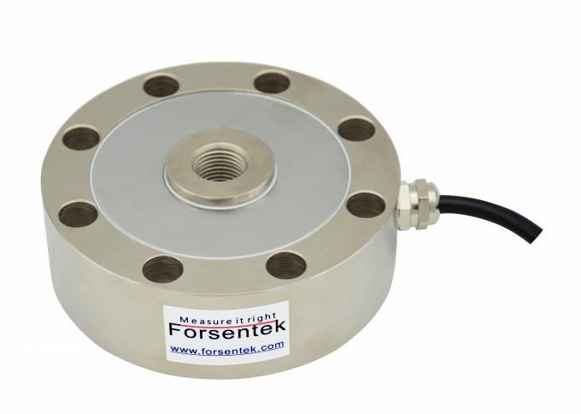
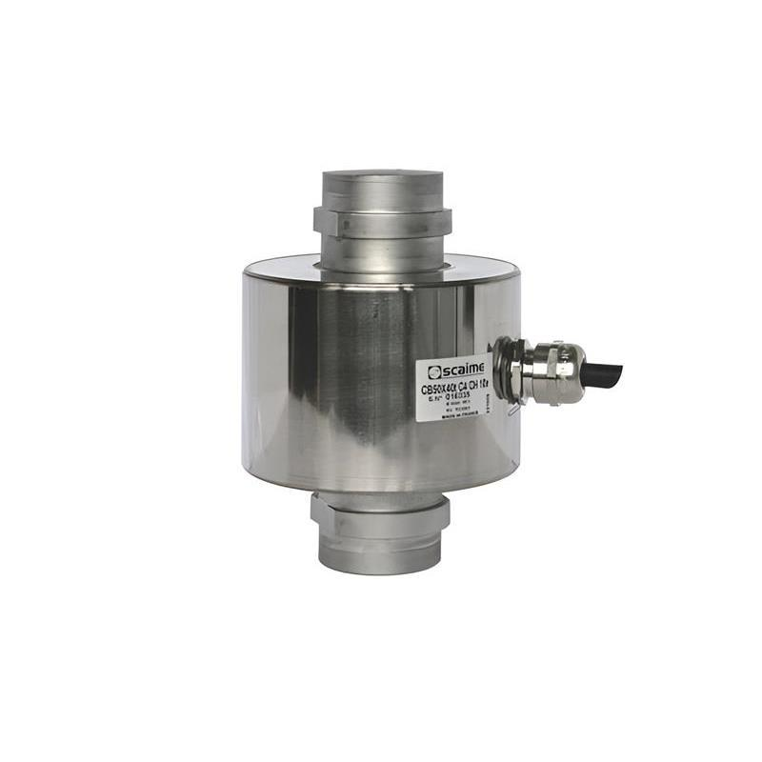
Description
Designed to measure compressive forces and heavy loads with excellent stability.
Applications
- Heavy-duty weighing
- Silos
- Presses
- Structural testing

4. Tension (S-Type) Load Cell
# Source: AI Source: Provided by: [Data Path: Persons Table -> ID Column: 1, Name_En Column: Motasem Essam] -> From: [ChatGPT] on [7/17/2026]
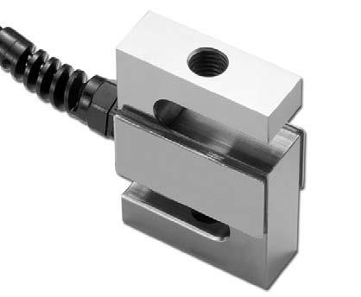
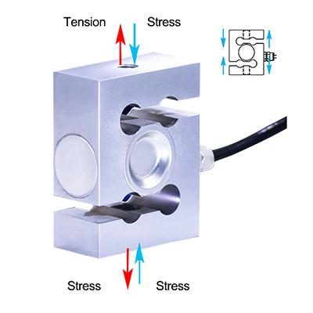
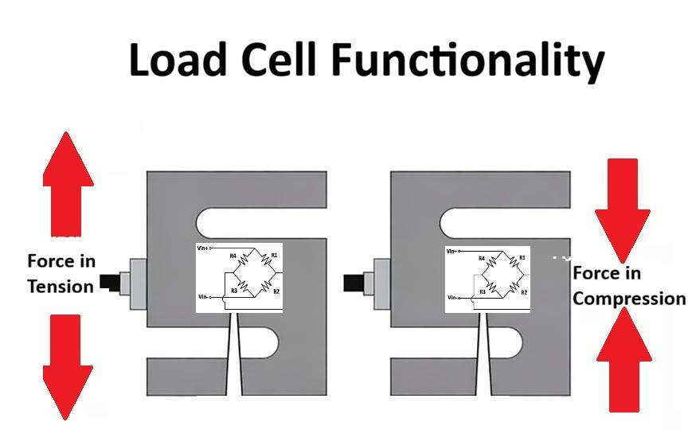
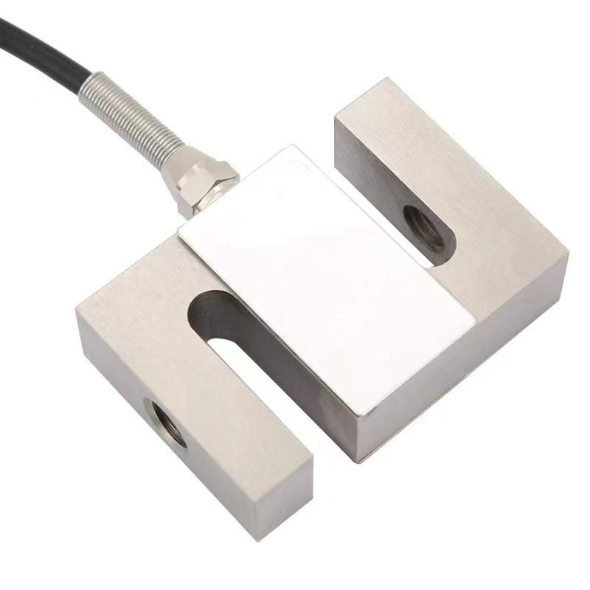
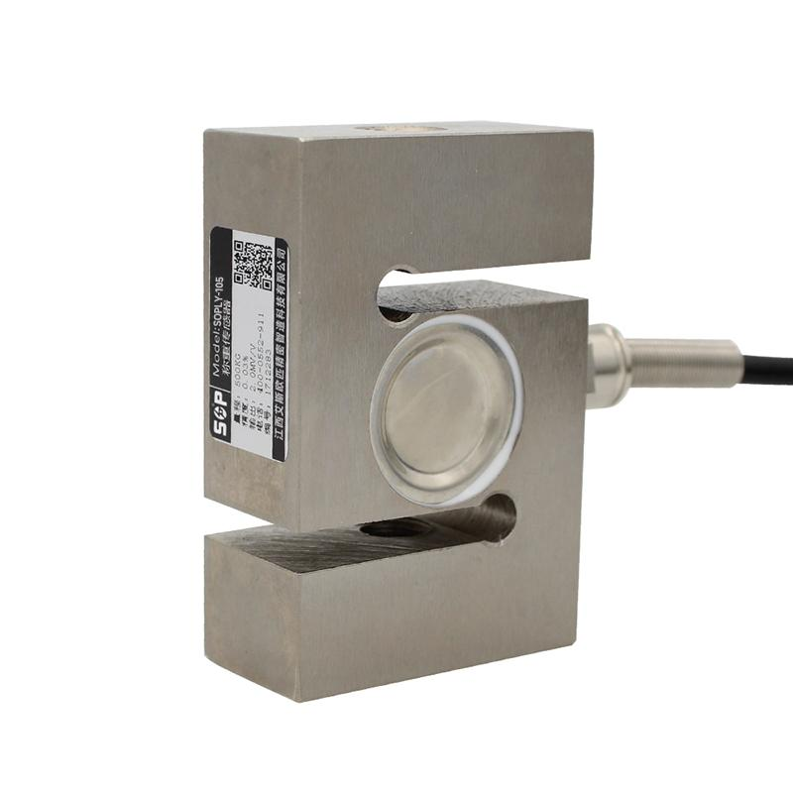
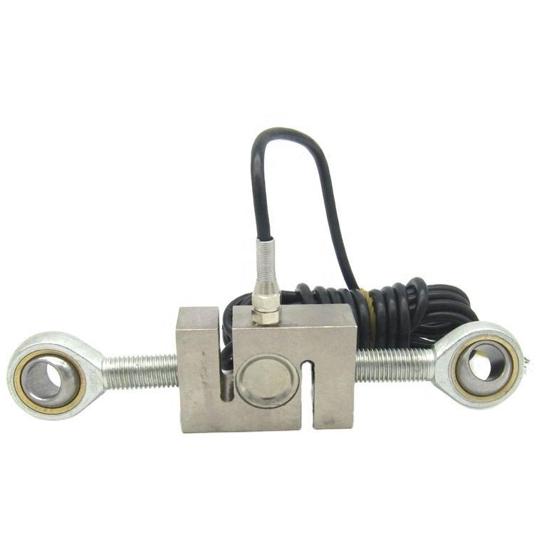
Description
Can measure both tensile and compressive forces. Its "S" shape makes it ideal for suspended loads.
Applications
- Crane scales
- Hanging scales
- Material testing
- Industrial force measurement

5. Canister Load Cell
# Source: AI Source: Provided by: [Data Path: Persons Table -> ID Column: 1, Name_En Column: Motasem Essam] -> From: [ChatGPT] on [7/17/2026]
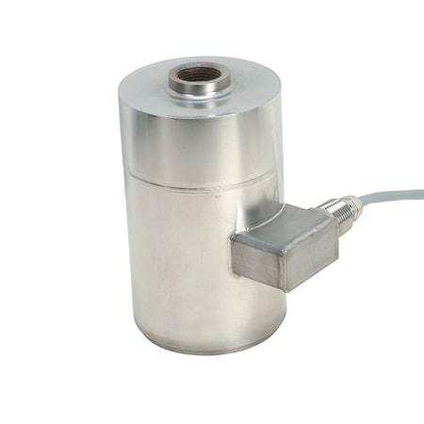
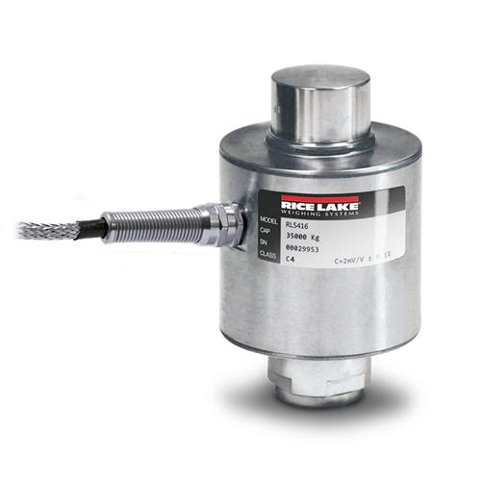
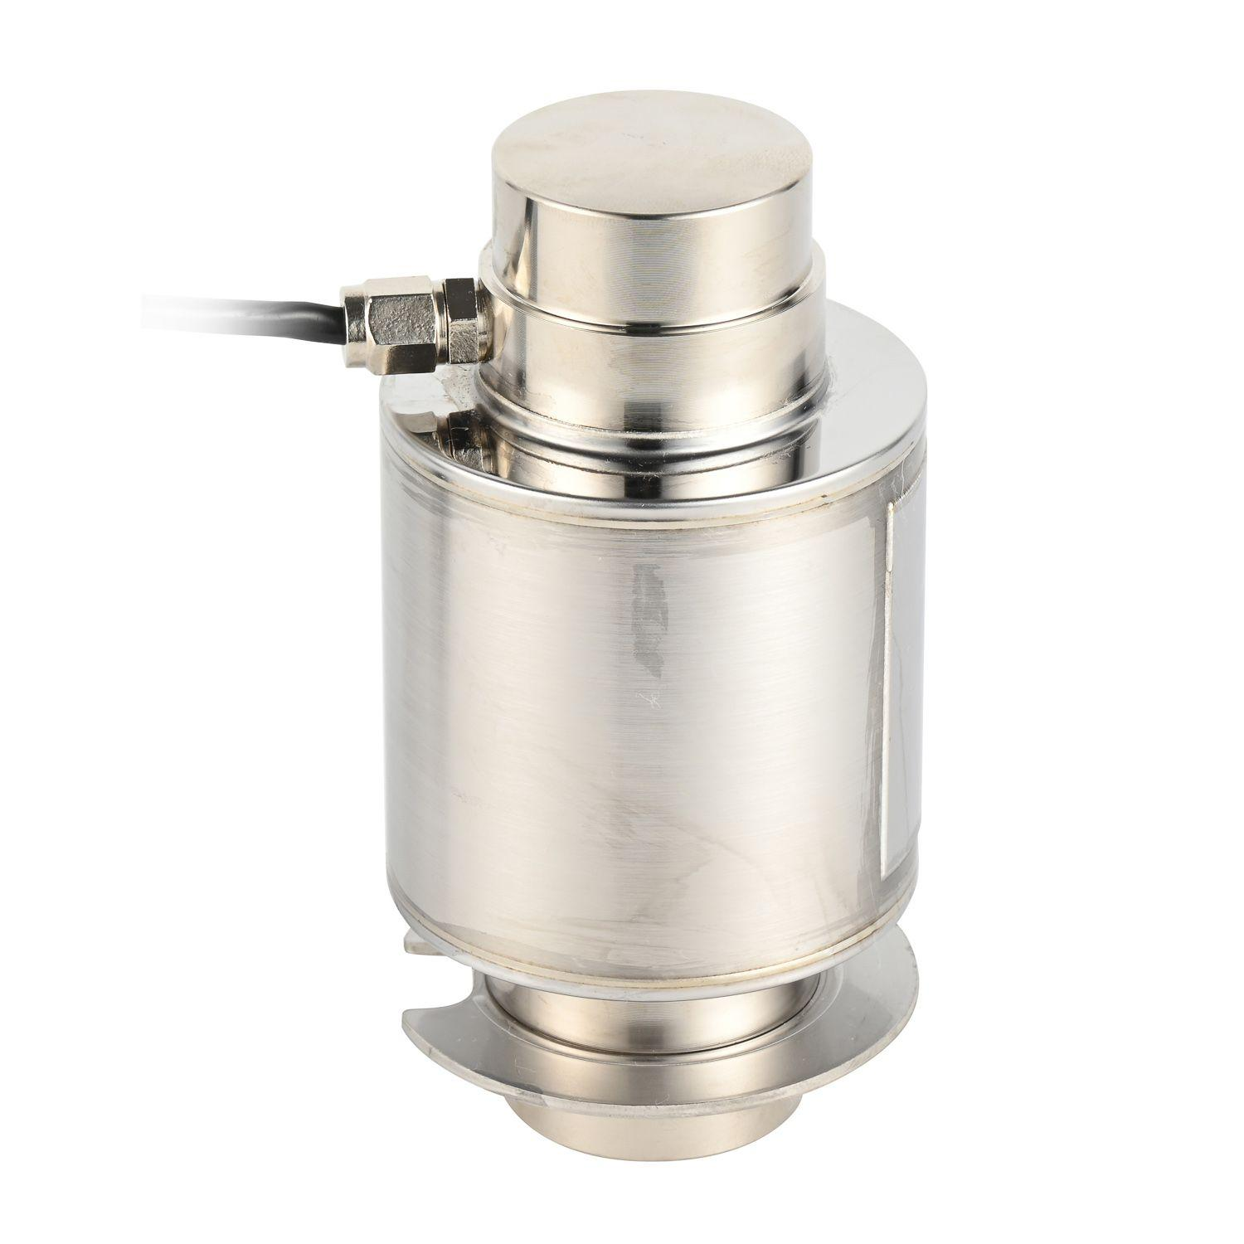
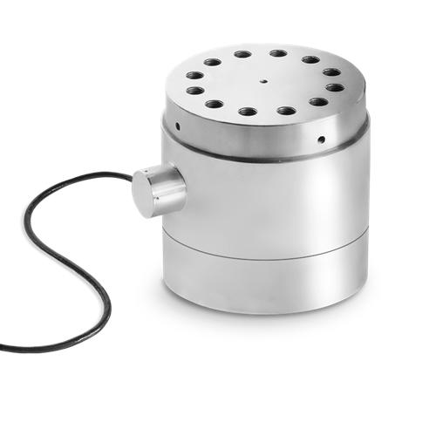
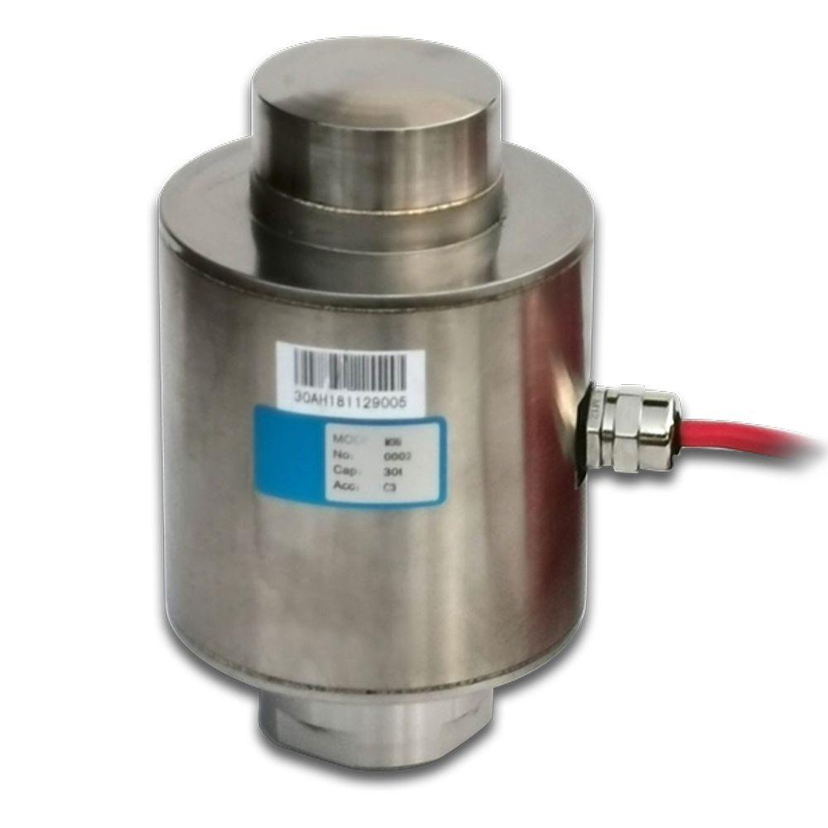
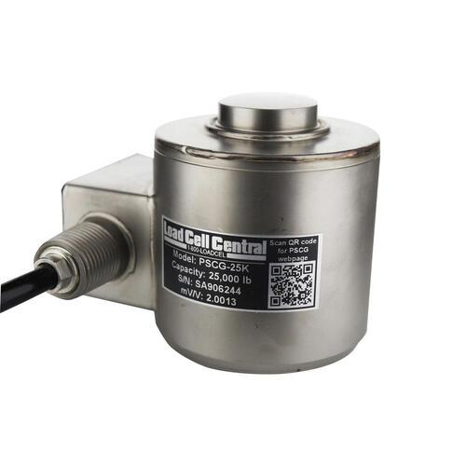
Description
A cylindrical load cell designed for extremely high-capacity compression measurements.
Applications
- Truck scales
- Railway scales
- Heavy industrial weighing
- Large storage tanks

6. Pancake (Low-Profile) Load Cell
# Source: AI Source: Provided by: [Data Path: Persons Table -> ID Column: 1, Name_En Column: Motasem Essam] -> From: [ChatGPT] on [7/17/2026]
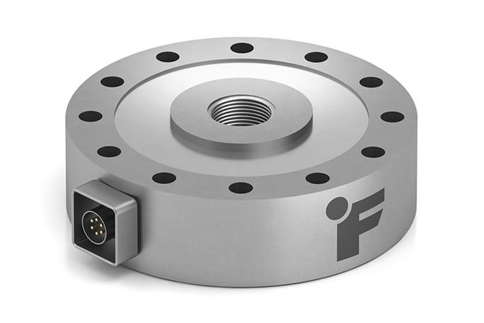
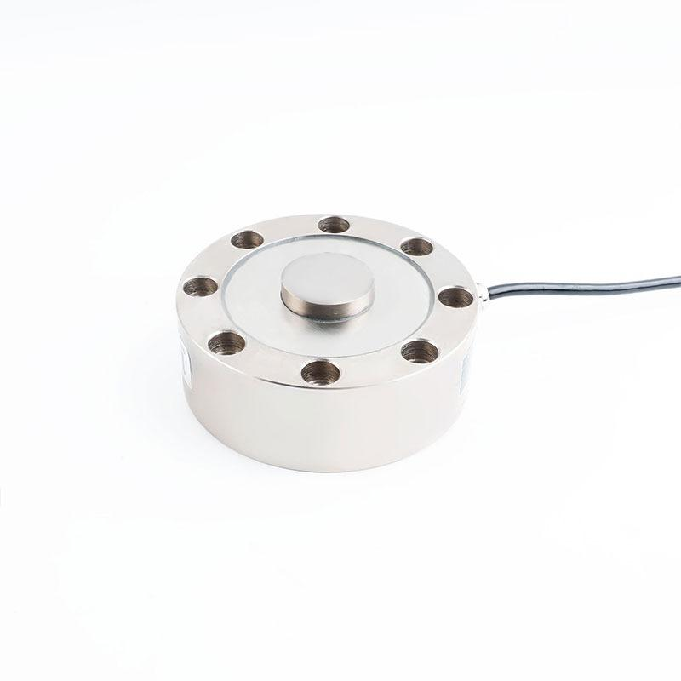
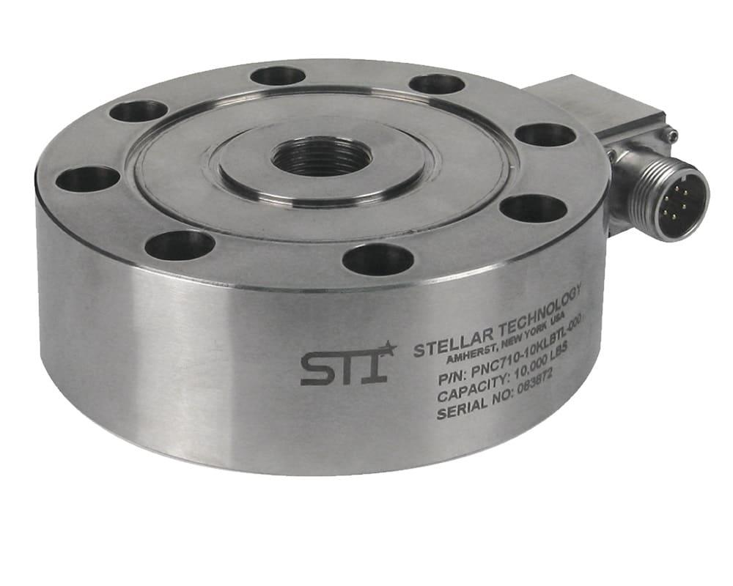
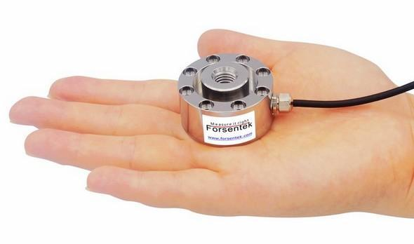
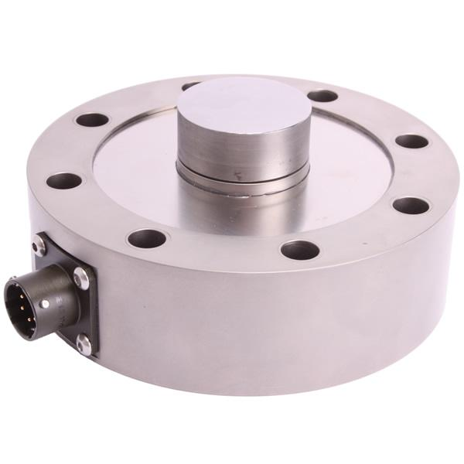
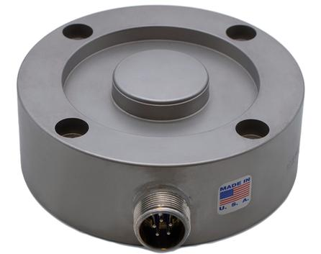
Description
A low-profile sensor capable of measuring both force and torque with high precision.
Applications
- Material testing
- Aerospace
- Robotics
- Research laboratories

7. Button Load Cell
# Source: AI Source: Provided by: [Data Path: Persons Table -> ID Column: 1, Name_En Column: Motasem Essam] -> From: [ChatGPT] on [7/17/2026]
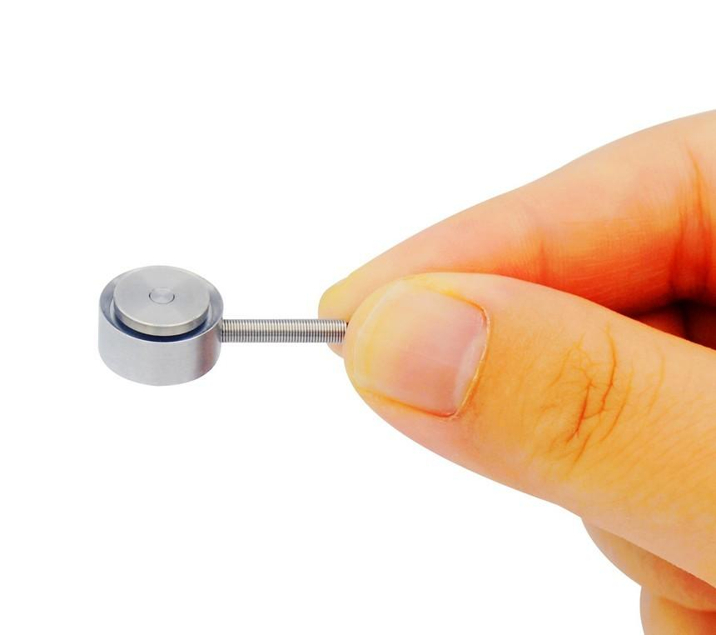
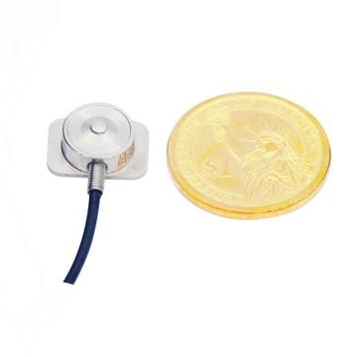
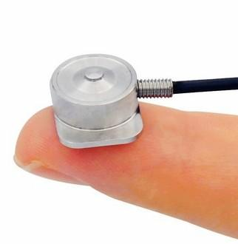
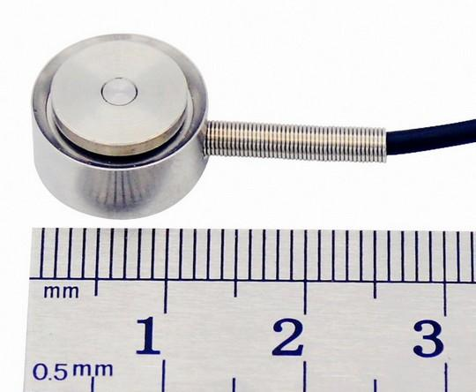
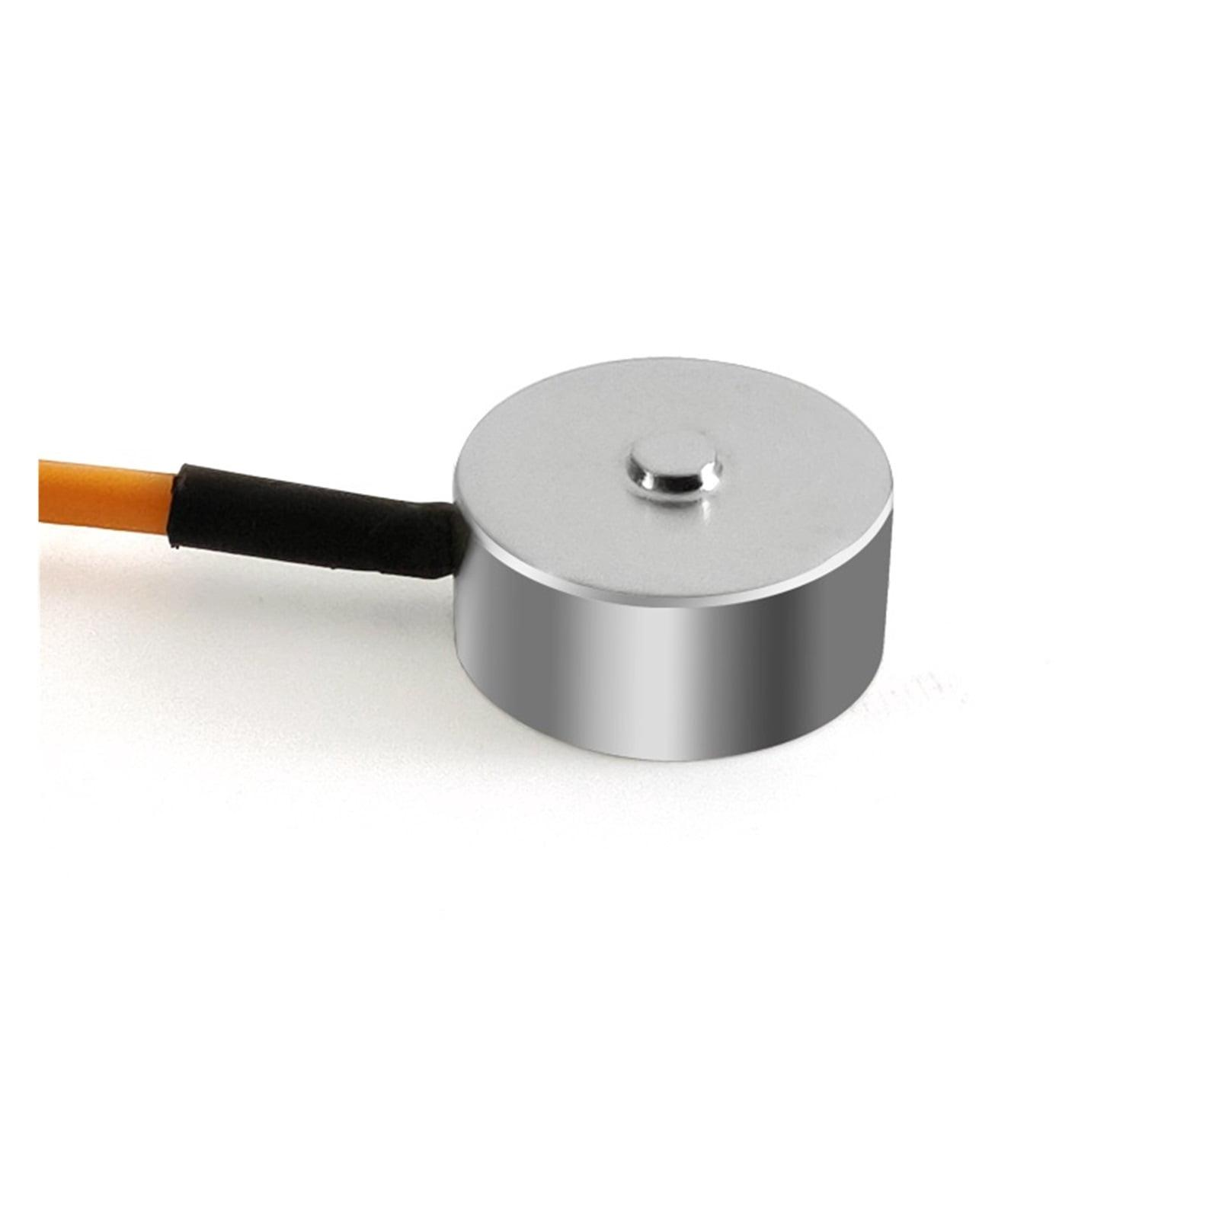
Description
A compact compression load cell designed for limited installation space.
Applications
- Medical devices
- Small presses
- Precision force measurement
- Laboratory equipment

8. Bending Beam Load Cell
# Source: AI Source: Provided by: [Data Path: Persons Table -> ID Column: 1, Name_En Column: Motasem Essam] -> From: [ChatGPT] on [7/17/2026]
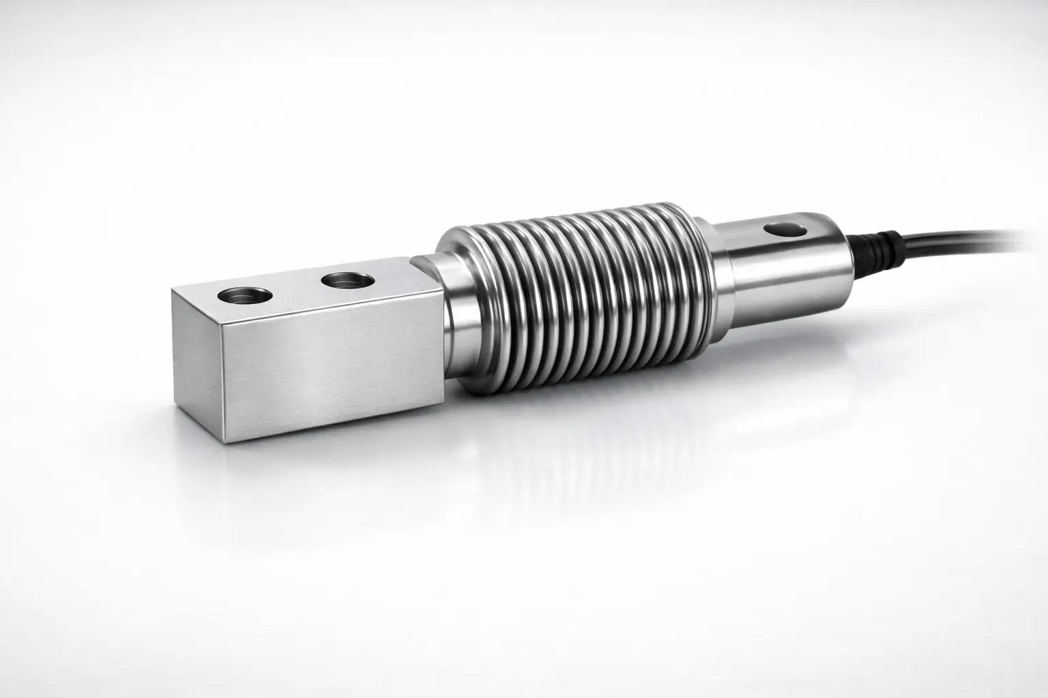
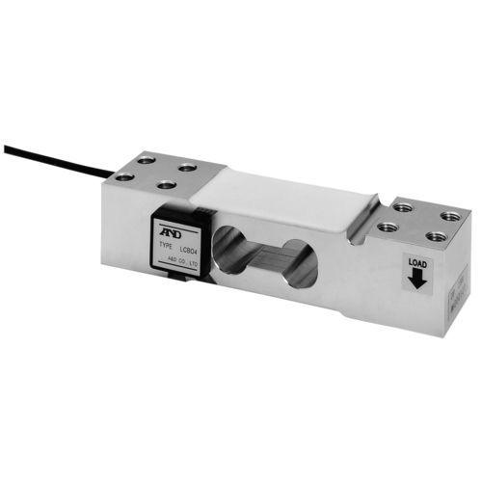
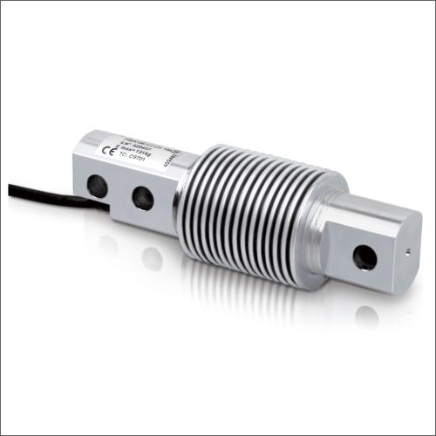
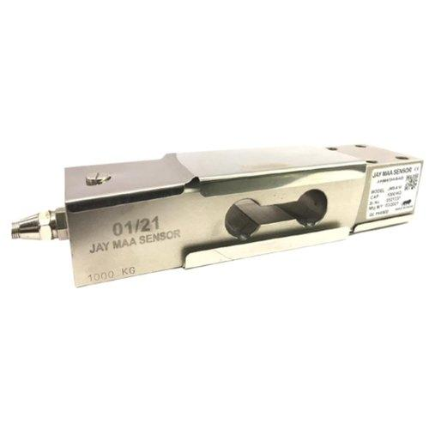
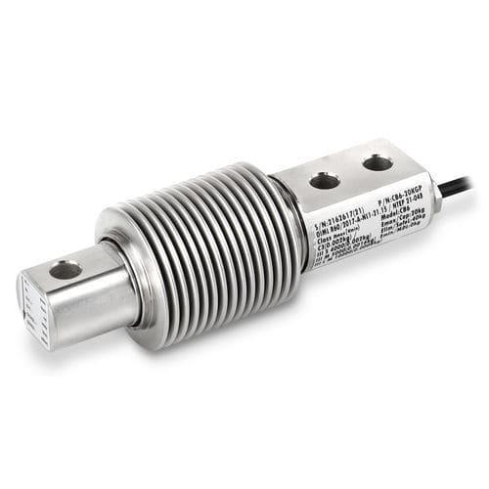
Description
Measures force through bending deformation of the beam under load.
Applications
- Bench scales
- Packaging machines
- Process weighing
- Conveyor weighing systems

Measuring Units
# Source: AI Source: Provided by: [Data Path: Persons Table -> ID Column: 1, Name_En Column: Motasem Essam] -> From: [ChatGPT] on [7/17/2026]
Load cells commonly measure:
- Newton (N)
- Kilonewton (kN)
- Kilogram (kg)
- Gram (g)
- Pound-force (lbf)
- Ton (t)

Measuring Range
# Source: AI Source: Provided by: [Data Path: Persons Table -> ID Column: 1, Name_En Column: Motasem Essam] -> From: [ChatGPT] on [7/17/2026]
The measuring range depends on the load cell design.
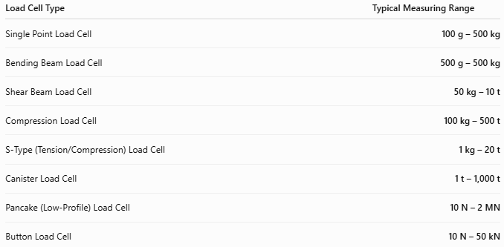
Load Cell Type | Typical Measuring Range
Single Point Load Cell | 100 g – 500 kg
Bending Beam Load Cell | 500 g – 500 kg
Shear Beam Load Cell | 50 kg – 10 t
Compression Load Cell | 100 kg – 500 t
S-Type (Tension/Compression) Load Cell | 1 kg – 20 t
Canister Load Cell | 1 t – 1,000 t
Pancake (Low-Profile) Load Cell | 10 N – 2 MN
Button Load Cell | 10 N – 50 kN

Resolution
# Source: AI Source: Provided by: [Data Path: Persons Table -> ID Column: 1, Name_En Column: Motasem Essam] -> From: [ChatGPT] on [7/17/2026]
Resolution is the smallest change in force or weight that the load cell system can detect.
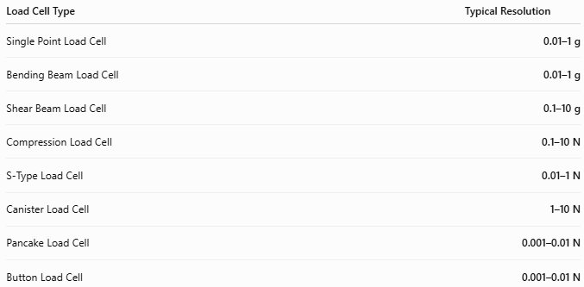
Load Cell Type | Typical Resolution
Single Point Load Cell | 0.01–1 g
Bending Beam Load Cell | 0.01–1 g
Shear Beam Load Cell | 0.1–10 g
Compression Load Cell | 0.1–10 N
S-Type Load Cell | 0.01–1 N
Canister Load Cell | 1–10 N
Pancake Load Cell | 0.001–0.01 N
Button Load Cell | 0.001–0.01 N

Accuracy
# Source: AI Source: Provided by: [Data Path: Persons Table -> ID Column: 1, Name_En Column: Motasem Essam] -> From: [ChatGPT] on [7/17/2026]
Accuracy indicates how closely the measured force matches the true applied force.
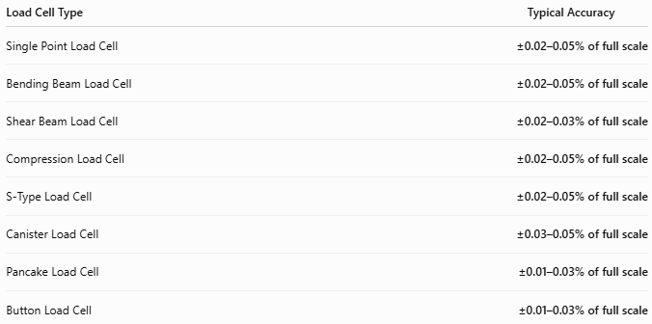
Load Cell Type | Typical Accuracy
Single Point Load Cell | ±0.02–0.05% of full scale
Bending Beam Load Cell | ±0.02–0.05% of full scale
Shear Beam Load Cell | ±0.02–0.03% of full scale
Compression Load Cell | ±0.02–0.05% of full scale
S-Type Load Cell | ±0.02–0.05% of full scale
Canister Load Cell | ±0.03–0.05% of full scale
Pancake Load Cell | ±0.01–0.03% of full scale
Button Load Cell | ±0.01–0.03% of full scale

Notes
- Load cells are among the most accurate force-measuring devices available.
- Accuracy depends on:
  - Calibration
  - Temperature compensation
  - Installation quality
  - Signal conditioning electronics
- Overloading beyond the rated capacity can permanently damage the sensing element.

How to Use a Load Cell
# Source: AI Source: Provided by: [Data Path: Persons Table -> ID Column: 1, Name_En Column: Motasem Essam] -> From: [ChatGPT] on [7/17/2026]
- Install the load cell correctly.
- Connect it to the signal conditioner or indicator.
- Zero (tare) the system.
- Apply the load gradually.
- Read the measured value.

Example
# Source: AI Source: Provided by: [Data Path: Persons Table -> ID Column: 1, Name_En Column: Motasem Essam] -> From: [ChatGPT] on [7/17/2026]
Displayed value:
2.35 kN
Measured force:
2.35 kilonewtons

Applications
# Source: AI Source: Provided by: [Data Path: Persons Table -> ID Column: 1, Name_En Column: Motasem Essam] -> From: [ChatGPT] on [7/17/2026]
Load cells are used in:
- Electronic weighing scales
- Industrial automation
- Tank weighing
- Hopper weighing
- Crane scales
- Material testing machines
- Structural monitoring
- Aerospace testing
- Robotics
- Medical equipment

Advantages
# Source: AI Source: Provided by: [Data Path: Persons Table -> ID Column: 1, Name_En Column: Motasem Essam] -> From: [ChatGPT] on [7/17/2026]
A load cell:
- Provides very high accuracy.
- Offers excellent repeatability.
- Measures static and dynamic loads.
- Easily interfaces with digital systems.
- Requires little maintenance.

Limitations
# Source: AI Source: Provided by: [Data Path: Persons Table -> ID Column: 1, Name_En Column: Motasem Essam] -> From: [ChatGPT] on [7/17/2026]
A load cell:
- Requires electrical power.
- Needs proper calibration.
- Can be damaged by overload.
- Is sensitive to installation errors.

Sources of Error
# Source: AI Source: Provided by: [Data Path: Persons Table -> ID Column: 1, Name_En Column: Motasem Essam] -> From: [ChatGPT] on [7/17/2026]
Instrument Errors
- Calibration drift
- Electronic noise
- Sensor aging
- Overload damage

User Errors
- Off-center loading
- Improper mounting
- Incorrect calibration

Environmental Errors
- Temperature changes
- Moisture
- Vibration
- Electromagnetic interference

Comparison with Other Force Measuring Instruments
# Source: AI Source: Provided by: [Data Path: Persons Table -> ID Column: 1, Name_En Column: Motasem Essam] -> From: [ChatGPT] on [7/17/2026]
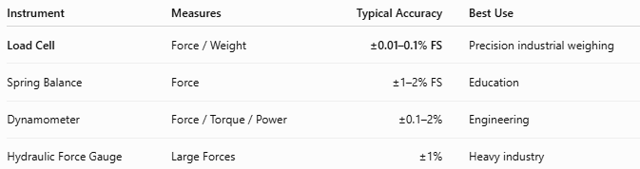
Instrument | Measures | Typical Accuracy | Best Use
Load Cell | Force / Weight | ±0.01–0.1% FS | Precision industrial weighing
Spring Balance | Force | ±1–2% FS | Education
Dynamometer | Force / Torque / Power | ±0.1–2% | Engineering
Hydraulic Force Gauge | Large Forces | ±1% | Heavy industry

Care and Maintenance
# Source: AI Source: Provided by: [Data Path: Persons Table -> ID Column: 1, Name_En Column: Motasem Essam] -> From: [ChatGPT] on [7/17/2026]
To maintain accuracy:
- Avoid overloads.
- Calibrate periodically.
- Protect cables and connectors.
- Keep the sensor clean and dry.
- Inspect mounting hardware regularly.

Common Mistakes
# Source: AI Source: Provided by: [Data Path: Persons Table -> ID Column: 1, Name_En Column: Motasem Essam] -> From: [ChatGPT] on [7/17/2026]
- Applying off-center loads.
- Exceeding the rated capacity.
- Ignoring calibration.
- Incorrect wiring.
- Poor mechanical installation.

Key Points
# Source: AI Source: Provided by: [Data Path: Persons Table -> ID Column: 1, Name_En Column: Motasem Essam] -> From: [ChatGPT] on [7/17/2026]
- A Load Cell converts force into an electrical signal.
- Most use strain gauge technology.
- Common types:
  - Single Point
  - Shear Beam
  - Compression
  - S-Type
  - Canister
  - Pancake
- Common units:
  - N
  - kN
  - kg
  - lbf
- Widely used in industrial weighing, automation, structural monitoring, and laboratory measurements.

Conclusion
# Source: AI Source: Provided by: [Data Path: Persons Table -> ID Column: 1, Name_En Column: Motasem Essam] -> From: [ChatGPT] on [7/17/2026]
A Load Cell is one of the most accurate and versatile force-measuring instruments available. By converting mechanical force into an electrical signal, it enables precise measurement of force and weight across a vast range of applications—from laboratory balances and industrial scales to aerospace testing and structural monitoring. Its high accuracy, repeatability, and compatibility with digital systems make the load cell the foundation of modern electronic weighing and force-measurement technology.

